Nutrition Conference
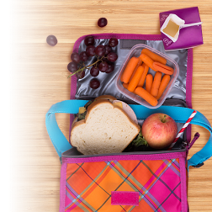
for parents

- Making healthy lunch boxes is not always easy?
- Having balanced meals for dinner is a challenge?
Come and meet a nutritionist who will give you tips and advice!

When? Thursday, March 19 (6 pm to 7:30 pm)
Where? Barclay School (main entrance)
Cost? Free

Danielle Charland Mika Joseph Ghislaine Paiement
School headmistress School nurse School Community Worker
----------------------------------------------------------------------------------------------------
Nutrition Conference for parents
Coupon to be given to Ghislaine Paiement by mars 17th 2020
Yes, I will come to the Nutrition conference on March 19th 2020.
No, I will not come.
Child's name: __________________________________ Group : ____________
Parent's name: ___________________________ Phone : __________________

